|  |
| --- |
|  |
| 新概念 3 册 |
| Lesson44 Speed and comfort |

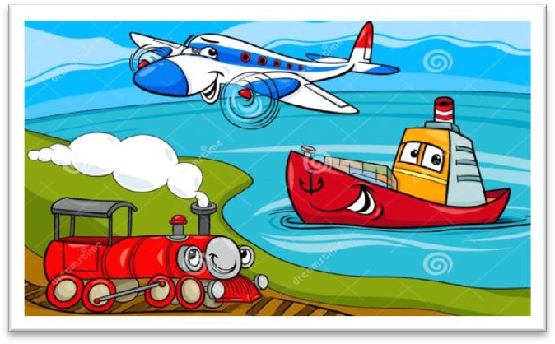

Book

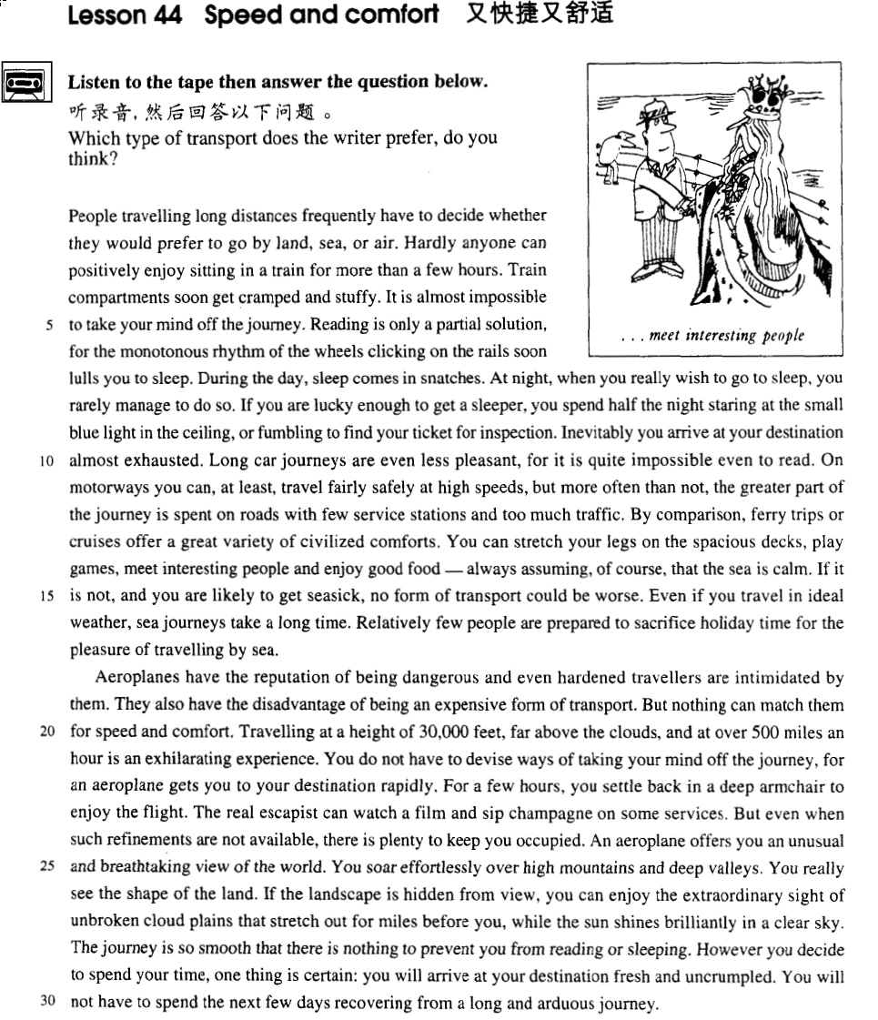

课文

People travelling long distances frequently have to decide whether they would prefer to go by land, sea, or air.

出远门的人常常需要决定是走旱路、水路，还是坐飞机。

Hardly anyone can positively enjoy sitting in a train for more than a few hours.

很少有人能够真正喜欢坐几个小时以上的火车。

Train compartments soon get cramped and stuffy.

车厢很快就变得拥挤、闷热，

It is almost impossible to take your mind off the journey.

想摆脱开旅途的困扰是很难的。

Reading is only a partial solution, for the monotonous rhythm of the wheels clicking on the rails soon lull you to sleep.

看书只能解决部分问题。车轮与铁轨间单调的嘎喳声很快就会送你进入梦乡。

During the day, sleep comes in snatches.

白天是忽睡忽醒，

At night, when you really wish to go to sleep, you rarely manage to do so.

到了夜晚，你真想睡了，却很难入睡。

If you are lucky enough to get a sleeper, you spend half the night staring at the small blue light in the ceiling, or fumbling to find your ticket for inspection.

即使你走运弄到一个卧铺，夜间有一半时间你会盯着车顶那盏小蓝灯而睡不着觉；要不然就为查票摸索你的车票。

Inevitably you arrive at your destination almost exhausted.

一旦抵达目的地，你总是疲惫不堪。

Long car journeys are even less pleasant, for it is quite impossible even to read.

乘汽车作长途旅行则更加不舒服，因为连看书都几乎不可能。

On motorways you can, at least, travel fairly safely at high speeds, but more often than not, the greater part of the journey is spent on roads with few service stations and too much traffic.

在公路上还好，你至少能以相当快的速度安全地向前行，但旅行的大部分时间都花在路上，而且只有很少的服务设施，交通也很拥挤。

By comparison, ferry trips or cruises offer a great variety of civilized comforts.

相比之下，坐船旅行或环游可以得到文明世界的各种享受。

You can stretch your legs on the spacious decks, play games, meet interesting people and enjoy good food -- always assuming, of course, that the sea is calm.

你可以在甲板上伸展四肢、做游戏，还能也很见到各种有趣的人，能享用各种美味佳肴-当然，这一切只有在大海风平浪静的情况下才有可能。

If it is not, and you are likely to get seasick, no form of transport could be worse.

如果大海肆虐起来，你就可能晕船，那种难受劲儿是任何一种别的旅行的方式都不会带来的。

Even if you travel in ideal weather, sea journeys take a long time.

即使风平浪静，坐船旅行也要占用很长时间。

Relatively few people are prepared to sacrifice holiday time for the pleasure of travelling by sea.

没有多少人会为享受坐船旅行的乐趣而牺牲假期的时间。

Aeroplanes have the reputation of being dangerous and even hardened travellers are intimidated by them.

飞机以危险而著称，连老资格的旅行者也怕飞机。

They also have the disadvantage of being an expensive form of transport.

飞机另一个缺点是昂贵。

But nothing can match them for speed and comfort.

但就速度与舒适而言，飞机是无与伦比的。

Travelling at a height of 30,000 feet, far above the clouds, and at over 500 miles an hour is an exhilarating experience.

腾云驾雾，在30，000 英尺高空以500英里的时速旅行，这种经历令人心旷神怡。

You do not have to devise ways of taking your mind off the journey, for an aeroplane gets you to your destination rapidly.

你不必想办法去摆脱旅途的困扰，因为飞机会迅速地把你送到目的地。

For a few hours, you settle back in a deep armchair to enjoy the flight.

几小时之内，你躺在扶手椅上，享受着旅途的欢乐。

The real escapist can watch a film and sip champagne on some services.

真正会享受的人还可以在某些航班上看一场电影和喝香槟。

But even when such refinements are not available, there is plenty to keep you occupied.

即使没有这些消遣条件，也总是有事可做。

An aeroplane offers you an unusual and breathtaking view of the world.

飞机上，你可以观察世界上非同寻常的奇妙的美景。

You soar effortlessly over high mountains and deep valleys.

你毫不费劲地飞越高山幽谷，

You really see the shape of the land.

你确能饱览大地的风貌。

If the landscape is hidden from view, you can enjoy the extraordinary sight of unbroken cloud plains that stretch out for miles before you, while the sun shines brilliantly in a clear sky.

如果这种景色被遮住了，你可以观赏一下展现在你面前的、一望数英里的、连绵不断的云海，同时阳光灿烂，天空清澈明朗。

The journey is so smooth that there is nothing to prevent you from reading or sleeping.

旅途平稳，丝毫不妨碍你阅读或睡眠。

However you decide to spend your time, one thing is certain: you will arrive at your destination fresh and uncrumpled.

不管你打算如何消磨时间，有件事是可以肯定的，即当你抵达目的地时，你感到精神焕发，毫无倦意，

You will not have to spend the next few days recovering from a long and arduous journey.

用不着因为漫长的旅途的辛苦而花几天时间休息来恢复精神。

词汇讲解

* **monotonous** [mə'nɒtənəs] adj. 无聊的，单调的
* Reading is only a partial solution, for the **monotonous** rhythm of the wheels clicking on the rails soon lulls you to sleep.
* The same old favorites recur year in year out **with monotonous regularity**（固定习语，“老是重复发生”）.
* The little boy wets the bed **with monotonous regularity**.

**【近义词组】**表达“单调的”：Lesson31

**dull**

* This invariably wins them the love and respect of others, for they add colour to the **dull** routine of everyday life.

**【词根】**

“**mon(o)**” = single 单调的

* **mono**logue （戏剧、电影等的）独白
* **mono**gamy 单配偶；单配性
* **mono**plane 单翼飞机
* a **monol**ingual dictionary 单语字典
* **mon**arch / **mon**archy 君主/君主制
* **click [klɪk]** v. 发出喀哒声
* **click** one’s fingers
* The door **clicked** shut.

**【总结】【复习】**拟声字：

* The soldier **clicked** his heels.
* He **slammed** / **banged** the door. （咣当）
* The door **slammed** / **banged** shut.
* **托福听力真题：**

A．The dog shut the door.

B．The shout was heard through the door.

C．The door of the bank was locked.

D．The door closed loudly.

* The door **banged** shut.
* Answer: (D) The door closed loudly.
* When Mrs. Richards walked towards him, he fled, **slamming** （咣当）the door behind him.
* If fifty pence pieces are not exchanged for sweets, they **rattle** （咣当）for months inside money boxes.
* As it was extremely heavy, he **dumped** （噔地一声）it on the counter.
* The order to abandon ship was given and hundreds of people **plunged** （扑通）into the icy water.
* They **plunged** into the lake, …
* We all **clapped** （拍手）our hands.
* Don’t **clatter** （落地声，撞击声）the dishes—you’ll wake the baby up.
* I’ll **smack** （啪的一声）your bottom if you don’t behave yourself.
* **inspection** [ɪn'spekʃn] n. 检查

**【词根】**

“**spect**” = look

* in**spect** / inspector / inspection
* ex**pect** / expectation
* su**spect** / suspicion / suspicious
* **spect**acle / spectacular
* circum**spect** / circumspection
* pro**spect**
* The road is tortuous, but the **prospects** are bright.
* retro**spect**
* **In retrospect**（回首往事）, I think my marriage was doomed from the beginning.
* **intimidate** [ɪn'tɪmɪdeɪt] v. 恐吓，威胁

**timid** adj. 胆小的

**【同根词】**

**intimidate** / **intimidating** / **intimidation**

* Hatred is the coward's revenge for being **intimidated**. —— George Bernard Shaw

**【近义词组】**表达“恐吓某人做某事…”：

**intimidate sb. into …**

**cow sb. into ...**

**bully sb. into …**

课文讲解

# （第一段）

# People travelling long distances frequently have to decide whether they would prefer to go by land, sea, or air.

**语法分析:**

People travelling long distances（非谓语动词做后置定语） frequently have to decide whether they would prefer to go by land, sea, or air. （宾语从句）

# Hardly anyone can positively enjoy sitting in a train for more than a few hours.

知识点（1）

**hardly anyone** = almost no one 很少有人、几乎没有人

**hardly anything** = almost nothing 几乎没有…

**hardly ever** = almost never 几乎从来没有过

* **Hardly anyone** writes to me these days.
* Dad ate **hardly anything**.
* Though he owned a large car, he **hardly ever** used it, preferring always to go on foot.

知识点（2）

**positively** adv. 英文解释：used to emphasize the truth of a statement, esp. when this is surprising （加强语气）真，真的很，真的是

* Some diets may be **positively** dangerous.
* Tonight's performance is **positively** the last time the band will appear together.

知识点（3）【课文仿写】

* **造句**：很少有人真喜欢几天以上吃同一种食物。
* Hardly anyone can positively enjoy eating the same food for more than a few days.

# Train compartments soon get cramped and stuffy.

知识点（1）

**compartment** （火车）小隔间

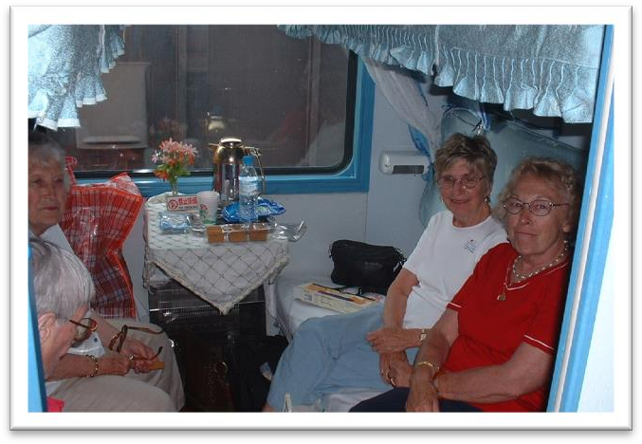

* ..., for she had sixteen watertight **compartments**.

知识点（2）

**cramped** 空间很狭小的

* a **cramped** room / office / cabin
* 造句：走廊 (corridor) 如此狭小我只好侧着身子 (edge my way) 走过去。
* The corridor was so cramped that I had to edge my way through it.

**【反义词】**

**spacious** 宽敞的

* You can stretch your legs on the **spacious** decks, ...

知识点（3）

**stuffy** 闷热的；闷人的；通风不畅的

* The room is too **stuffy**. Please open the window to allow the air to circulate.

**【区分】**

**stuffed** 已经喂饱了的；塞满了的

# It is almost impossible to take your mind off the journey.

知识点（1）

**take one’s mind off sth.** 转移注意力，不再想（不愉快的事）…

* It is almost impossible to **take my mind off** my dog’s death.
* The good thing about running is that it **takes my mind off** any problems I've got.
* She found that hard work was the best way to **take her mind off** her sorrow.

**【复习】**Lesson30

**be haunted by …** 不愉快的情绪总是缠着某人

* I **am haunted by** homesickness.
* After 30 years he **is still haunted by** the experience of fighting in Vietnam.

**【复习】**Lesson20

**take ... off ...** 把…从…里拿走

* She was so pretty — I couldn't **take** my eyes **off** her.
* "Have you seen James without his beard?" “I know — it **takes** years **off** him!”

**take time off** 请假；（off副词）

**take a day off**  请一天的假

**take the afternoon off** 请一下午的假

* **走遍美国**
* Do you still live there?
* Oh yes, yes. My husband‘s there now. He couldn't **take time off** to come to New York with me.
* I have to **take time off** from work / school to go to the dentist.

# Reading is only a partial solution, for the monotonous rhythm of the wheels clicking on the rails soon lull you to sleep.

**语法分析:**

Reading is only a partial solution, for the monotonous rhythm of the wheels clicking on the rails（后置定语,修饰wheels） soon lulls you to sleep. （for...原因状语)

知识点（1）

**partial** 部分的；不完全的

* a **partial** solution / success
* a **partial** solar / lunar eclipse 日/月偏食
* a total solar / lunar eclipse 日/月全食

知识点（2）【课文仿写】

* A truly dedicated bargain hunter must have patience, and **above all**（最重要的是）, the ability to recognize the worth of something when he sees it.
* Rastus **leads an orderly life**（有规律的生活）.
* **造句**：吃药只能解决部分问题, 最重要的是你必须要过有规律的生活。
* Taking medicine is only a partial solution, and **above all,** you have to **lead an orderly life**.

知识点（3）

**rhythm** 节奏

**beat** 节拍

**melody** 旋律

* Let’s dance to the **beat**.

知识点（4）

**lull sb. to sleep** 使某人入睡

* lull a baby to sleep

**lullaby** 摇篮曲

* **造句**：这梦幻般的音乐使我沉沉睡去。
* The dream-like music **lulls me to sleep**.

**sleep comes in snatches** 忽睡忽醒

* During the day, **sleep comes in snatches**.

**toss and turn** 辗转反侧，难以入眠

* **听力真题：**

A．Both of us were exhausted.

B．We always tried to rest after exercising.

C．I turned over and went to sleep again.

D．I was overtired and couldn't sleep.

* Last night I **tossed and turned** in bed, too exhausted to sleep.
* Answer: (D) I was overtired and couldn't sleep.

# During the day, sleep comes in snatches.

# At night, when you really wish to go to sleep, you rarely manage to do so.

# If you are lucky enough to get a sleeper, you spend half the night staring at the small blue light in the ceiling, or fumbling to find your ticket for inspection.

**语法分析:**

If you are lucky enough to get a sleeper（if... 条件状语从句）, you spend half the night **staring** at the small blue light in the ceiling, or（并列） **fumbling** to find your ticket for inspection.

知识点（1）

**sleeper** n. 1. 卧铺车；卧铺车厢；卧铺床位

**sleeper** n. 2. 睡觉的人

* a light / heavy sleeper

知识点（2）【复习】

**语法：形容词的顺序**

**大小 形状 年龄 新旧 颜色 国际 材料 用途 + 中心名词**

* a little white lamb
* small black boxes

知识点（3）【复习】

介词 **in**

* As we were walking past a shop, he held a diamond firmly against the window and made a deep impression **in** the glass.
* He hit me **on** the nose.
* He hit me **in** the face.

# Inevitably you arrive at your destination almost exhausted.

知识点（1）【复习】

**inevitably** adv. 必然，不可避免

* **Inevitably** the repair job was not quite so simple.

**inevitable** adj. 必然的，不可避免的

* Those who make peaceful revolution impossible will make violent revolution **inevitable**. —— John F. Kennedy

**【近义词组】**表达“避免”：

**sth. can’t be helped** 某事不可避免

* **托福听力真题：**

A．She can't help the man look for another platter.

B．She forgot the platter had been broken.

C．She didn't realize the platter had been broken.

D．She doesn't want the man to replace the platter.

* M: I don’t know how I managed to break that platter. I’ll be more than happy to buy you a new one.
* W: Forget about it. **Some things just can’t be helped**.
* Q：What does the woman mean?
* Answer: (D) She doesn't want the man to replace the platter.

知识点（2）【复习】

* … you arrive at your destination almost **exhausted**(主语补足语).
* …, you will arrive at your destination fresh and **uncrumpled**(主语补足语).
* When I got home, I was tired and **sleepy**(主语补足语).
* I got home **tired** and **sleepy**(主语补足语).

# Long car journeys are even less pleasant, for it is quite impossible even to read.

知识点（1）

* ~~…, for you are quite impossible to read.~~ X 错误， impossible主语不能是人

# On motorways you can, at least, travel fairly safely at high speeds, but more often than not, the greater part of the journey is spent on roads with few service stations and too much traffic.

**语法分析:**

On motorways you can, *at least（插入语）*, travel fairly safely at high speeds, but（并列连词，转折） *more often than not（副词短语，状语）*, the greater part of the journey is spent on roads with few service stations and too much traffic（后置定语,修饰roads）.

知识点（1）

**motorway** 【英】高速公路

**expressway** / **freeway** 【美】高速公路

知识点（2）

**more often than not** 【idiom】通常

= **as often as not**

= **usually**

* **More often than not**, the arguments could have been avoided.

**【近义词组】**表达“经常”：

**all too often** （贬义，不愉快的事经常发生）

* **All too often**, parents leave their children home alone.

**【扩展】**表达“时而，有时候”：

**every so often**

* She still calls me **every so often**.

**sometimes**

**occasionally**

**once in a while**

**from time to time**

**(every) now and then**

**(every) now and again**

知识点（3） Lesson39

**petrol / service station** 【英式】加油站

**gas station** 【美式】加油站

注意：课文service stations翻译错误

知识点（4）

**traffic** [U]

* Meanwhile, the **traffic** piled up behind.

知识点（5）【课文仿写】

* Some of my acquaintances in the country come up to town once or twice a year to visit the theatre as a special treat.
* **造句**：我的几个住在乡下的熟人每年进城一两次来看戏，对他们来说这是一种特殊的享受了， 但是通常旅程中大部分时间花在了路上，在路上加油站很少，车辆却很多。
* Some of my acquaintances in the country come up to town once or twice a year to visit the theatre as a special treat, but more often than not, the greater part of the journey is spent on roads with few service stations and too much traffic.

# By comparison, ferry trips or cruises offer a great variety of civilized comforts.

知识点（1）

**by / in comparison** 相比之下

**【扩展】**

**pale in / by comparison** 相形见绌

* I thought I was badly treated but my experiences **pale in comparison** with yours.

**【近义词组】**表达“相比之下”：

**by / in contrast**

* A run-down watch is still a watch and can be rewound. An old watch, **by contrast**, becomes so worn and unreliable that it eventually is not worth mending.
* In his own lifetime Galileo was the centre of violent controversy; but the scientific dust has long since settled, and today we can see even his famous clash with the Inquisition in something like its proper perspective. But, **in contrast**, it is only in modern times that Galileo has become a problem child for historians of science.

**【近义词组】**表达“与…相对照”：

**compared with / to ...**

**in / by comparison with / to ...**

**in / by contrast with / to ...**

* It's as if they were, in some sense, cosmic beings **in** violent and lovely **contrast with** us suburban creatures.

**【近义词组】【扩展】【进阶】**

**A as against B is as C against D**  A与B相比，就如同C与D相比一样

* The military power of the US, **as against** that of DPRK, **is as** the strength of an elephant **against** that of a mouse.

知识点（2）

**comforts** n. 使人感觉舒适的事物 （习惯复数）

* hotels with all the modern **comforts**
* After the trip, it was nice getting back to a few home **comforts**.

# You can stretch your legs on the spacious decks, play games, meet interesting people and enjoy good food -- always assuming, of course, that the sea is calm.

知识点（1）复习

**stretch one’s legs** 舒活筋骨

**【复习】**表达“散步”：

**take a walk / stroll**

**have a walk / stroll**

**go for a walk / stroll**

* He usually **takes a short walk** in the evenings and is always home by seven o'clock.
* The idea never appealed to me very much, but one day, after heavy shower, I happened to be walking in my garden when I noticed a huge number of snails **taking a stroll** on some of my prize plants.
* **走遍美国**
* What do you want to do after breakfast? Why don't we **take a walk** down to the river?
* **老友记**
* Phoebe: Hey, is Chandler here? Joey: No, no he **went for a walk**.

知识点（2）

**meet** 结识、结交

* One wants to **meet** like-minded collectors, …

知识点（3） Lesson36

**assuming (that) …** 1.以为；2.假定，假如

* **Assuming that** （以为）his family had been killed during an air raid, Hans settled down in a village fifty miles away where he had remained ever since.
* **造句**：你将用半小时到那里——当然假定路上车不多的话。
* You’ll get there in half an hour —**assuming**（假如）, of course, that the traffic is not heavy.

# If it is not, and you are likely to get seasick, no form of transport could be worse.

**语法分析:**

If it is not (calm省略), and（条件内部的并列） you are likely to get seasick（if... 条件状语从句）, no form of transport could be worse.

知识点（1）

**transport [英] / transportation [美]** 泛指交通工具、方式

* public **transport** / **transportation**
* A lot of people object to mobile phones, especially when they are used in public places like restaurants or on **public transport**.

知识点（2）Lesson23

**语法**：否定词+比较级=最高级

* **Nothing** could have been **more** annoying.
* **No** creature has received **more** praise and abuse than the common garden snail.
* There is **no quicker** method of disposing of patients than by giving them what they are asking for.
* **Nothing can be compared**, he maintains, **with** the first cockcrow, the twittering of birds at dawn, the sight of the rising sun glinting on the trees and pastures.
* But **nothing can** match them for speed and comfort.

**【复习】【扩展】**Lesson2 最高级的表达

* **Nobody equals / matches** him in strength.
* In English she **has no equal** in her class.
* **托福听力真题：**
* In computer programming, Susan **is head and shoulders above** the rest of us.

# Even if you travel in ideal weather, sea journeys take a long time.

# Relatively few people are prepared to sacrifice holiday time for the pleasure of travelling by sea.

知识点（1）

**relatively** **few / easy / new / minor …** 相对比较…

* Cave exploration, or pot-holing, as it has come to be known, is a **relatively new** sport.

知识点（2）

**be prepared to do** = **be willing / ready to do** 乐意、愿意做…

* Why people **are prepared to tolerate** a four-hour journey each day for the dubious privilege of living in the country is beyond me.

知识点（3） Lesson4

**sacrifice … for …** 为了（后者）…而牺牲（前者）…

* Such is human nature, that a great many people are often willing to **sacrifice** higher pay **for** the privilege of becoming white-collar workers.

知识点（4）【课文仿写】

* **造句**：没有多少人愿意为了钱而牺牲掉自己作为人的尊严。
* Relatively few people are prepared to sacrifice their human dignity for money.

# （第二段）

# Aeroplanes have the reputation of being dangerous and even hardened travellers are intimidated by them.

知识点（1）

**have the reputation of being …** 有这样…一个名声

* She **has the reputation of being** a **good** doctor.
* Peter **has the reputation of being** the **worst** boy in the class.

知识点（2） Lesson11

**hardened** adj. 英文解释：someone who is hardened has had a lot of difficult or unpleasant experiences and is no longer much affected by such things 老练的，老资格的，见怪不怪的，麻木不仁的

* The **hardened** professional smuggler, on the other hand, is never troubled by such feelings, even if he has five hundred gold watches hidden in his suitcase.

# They also have the disadvantage of being an expensive form of transport.

知识点（1）

**have the disadvantage of …** 有…的劣势

* He **has the disadvantage of being** unable to drive a car.

have the advantage of … 有…的优势

* Though she **has the twin advantages of** wealth and beauty, she doesn’t live a happy life.

# But nothing can match them for speed and comfort.

# Travelling at a height of 30,000 feet, far above the clouds, and at over 500 miles an hour is an exhilarating experience.

**语法分析:**

Travelling *at a height of 30,000 feet, far above the clouds, and at over 500 miles an hour （3个并列后置定语）*is an exhilarating experience.

知识点（1）

**exhilarating** adj. 令人极其兴奋和高兴的

* There is nothing more **exhilarating** than to be shot at without result. —— Sir Winston Churchill

# You do not have to devise ways of taking your mind off the journey, for an aeroplane gets you to your destination rapidly.

知识点（1）

**devise** 设计出

* They **devise** hundreds of competitions which will enable us to win huge sums of money.

# For a few hours, you settle back in a deep armchair to enjoy the flight.

知识点（1）

**settle** 含义1：v. 舒适地坐到……

* **settle** back in a deep armchair
* We **settled** in front of the television for the evening.
* Jessica **settled** herself on the sofa with a small sigh of relief.

**settle** 含义2：v. 驻扎在某个地方……

* Six hundred years ago, Sir John Hawkwood arrived in Italy with a band of soldiers and **settled** near Florence.

**settle** 含义3：v. 定居……

* Assuming that his family had been killed during an air raid, Hans **settled** down in a village fifty miles away where he had remained ever since.
* He had often dreamed of retiring in England and had planned to **settle** down in the country.

**settle** 含义4：v. 解决问题……

* The two men quarrelled bitterly and it was clear that the argument could only be **settled** by a fight.

# The real escapist can watch a film and sip champagne on some services.

知识点（1）

**escapist** n. 遁世逍遥者，逃避现实生活一心享受的人

知识点（2）

**service** n. 英文解释：BrE a regular journey made by a bus, train, boat, plane etc to a particular place at a particular time **汽车，火车，轮船，飞机等的班次**

* the 8:15 **service** to Cambridge

# But even when such refinements are not available, there is plenty to keep you occupied.

知识点（1）

**refinement** 使事物变得更好

* With several **refinements** your essay would be excellent.

知识点（2）

**occupy** vt. 占据（时间，空间等）

* A little later, a man came along with a biscuit which **occupied** the whole boot of his car.
* Mainframe computers were very large indeed, often **occupying** whole air-conditioned rooms, employing full-time technicians and run on specially-written software.

**occupied** adj. 忙的，有事做的

**keep sb. occupied** 使某人有事可做

* We need something to **keep the children occupied**.

# An aeroplane offers you an unusual and breathtaking view of the world.

知识点（1）

**breathtaking** 激动人心的；惊人的

* The West Lake is **breathtakingly** beautiful!

**take a … breath** （惊叹）吸气

* He **took a deep breath** to compose himself.

# You soar effortlessly over high mountains and deep valleys.

# You really see the shape of the land.

# If the landscape is hidden from view, you can enjoy the extraordinary sight of unbroken cloud plains that stretch out for miles before you, while the sun shines brilliantly in a clear sky.

**语法分析:**

If the landscape is hidden from view（if... 条件状语从句）, you can enjoy the extraordinary sight of unbroken cloud plains that stretch out for miles before you（that ...定语从句）, *while the sun shines brilliantly in a clear sky（时间状语从句）*.

知识点（1）

**landscape** 含义1：n. scenery of an area of land （陆上的）风景, 景色

**landscape** 含义2：n. picture showing a view of the countryside 野外风景画

# The journey is so smooth that there is nothing to prevent you from reading or sleeping.

知识点（1）

**prevent sb. from doing** 防止、组织某人做某事

* **造句**：在新社会, 每个孩子都能接受良好的教育。
* In the new society, there is nothing to **prevent** a child **from receiving** good education.
* Despite its immensity, it is both simple and elegant, **fulfilling its designer's dream**（实现了…的梦想） to create 'an enormous object drawn as faintly as possible'.
* **造句**：她既有天赋又这么勤奋, 一定能实现自己的梦想。
* She is so talented and diligent that there is nothing to **prevent her from fulfilling her dream.**

# However you decide to spend your time, one thing is certain: you will arrive at your destination fresh and uncrumpled.

**语法分析:**

However you decide to spend your time（让步状语从句）, one thing is certain: *you will arrive at your destination fresh and uncrumpled（做*one thing*同位语）*.

知识点（1）【课文仿写】

* 造句：无论在前进的道路上 (on our road ahead) 遇到 (encounter) 什么样的困难, 有一件事是肯定的: 只要 (so long as) 我们坚持 (persist) 就一定能克服它 (manage to overcome it)。
* Whatever difficulty we may encounter on our road ahead, one thing is certain: *we will manage to overcome it so long as we persist*.

# You will not have to spend the next few days recovering from a long and arduous journey.

知识点（1）Lesson43

**recover from …** 从……中恢复

**recover sth.** 恢复了……

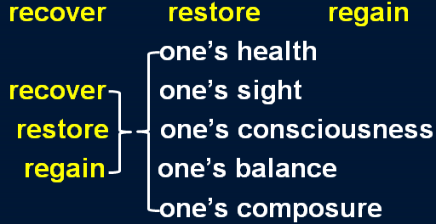

**recover sth.** 重新获得，找回，赚回，补偿

* But the claim made by a local authority to **recover** the cost of salvaging a sunken pie dish must surely be unique.

知识点（2）Lesson35

**arduous** adj. 艰苦的, 费力的

* Justice is part of the complex machinery of the law. Those who seek it undertake an **arduous** journey and can never be sure that they will find it.